History of the Americas IA: Historical Investigation

Research Process:

Taking stock and next steps



What students don’t know about research: A Key Distinction
“Finding out about a topic” is not research.
This approach treats the discovery of existing information as its goal.

Genuine research demands some sort of problem-solving, that is, critical analysis leading to a conclusion. Research uses information as a tool to try to solve a problem, issue, or controversy. Its purpose is analysis and problem-solving not just summarizing what you know about the topic.
Badke, “What students don’t know about research,” http://williambadke.com/TeachingResources.htm

Taking stock with your Annotated Bibliography
Jot down what you know and what you think
This is important because it helps you develop an argument about the question.
(Adapted from “History” handout, The Writing Center, University of North Carolina at Chapel Hill, https://writingcenter.unc.edu/tips-and-tools/history/ )
For each annotated bibliography source, make two lists, one of facts and one of thoughts.
Facts and information | Thoughts
…about the source itself:  Return to the MLA citation you provided for your source in the bibliography, and identify the key facts. This corresponds closely to the “Origin” category of your OPVCL:  - Who authored it?  - What did they title it? What’s the specific topic?  - What kind of text is it? (encyclopedia or reference entry; academic article, chapter, or book; newspaper article, opinion piece; essay in a magazine; speech or public address)  - Where was it originally published (or publicized)? (look for the italicized part of the citation)  - When was it published (or publicized)?  …about the content of the source:  Rereading your annotated bibliography entry and notes, make a quick list of the facts or information you plan to use. | …about the source itself:  While considering the facts you identified about the source in its MLA citation, review your annotated entry for the source and list your thoughts related to “Origin” and “Purpose”:  - What is usually the purpose for this kind of text? How do the specific purposes of the source follow, amplify, or deviate from the usual purpose? (encyclopedia entries contain facts for reference, newspaper articles arrange facts and quotes to tell a story about an event or person)  - Can you identify a question or problem that the author of this source is trying to answer or solve in this text? How does that question or problem relate to your research question?  ….about the content of the source:  What aspect of your research question do these facts and/or information relate to? With respect to your research question, can you identify one or more “smaller” or more specific questions that the facts and information can be used to answer?  Ask yourself these questions and list your responses. Your responses will help you identify main points for your essay outline (and paragraph topic sentences). Your responses will also help you revise and refine your research question to direct your investigate at what really interests you.  What’s the relationship between these facts?  What’s your reaction to them? What surprised or excited you?  What conclusions might a reasonable person draw?  What do you want to know now? What do you need to know now to continue building an answer to your research question?  You might consider or classify how each source contributes to answering your research questions with reference to the six concepts of IB History:  Change, Continuity, Causation, Consequence, Significance, Perspectives  Your responses (or difficulty coming up with any) can also let you know whether a source is really worth including in your investigation, and what kind of source you want to look for instead…

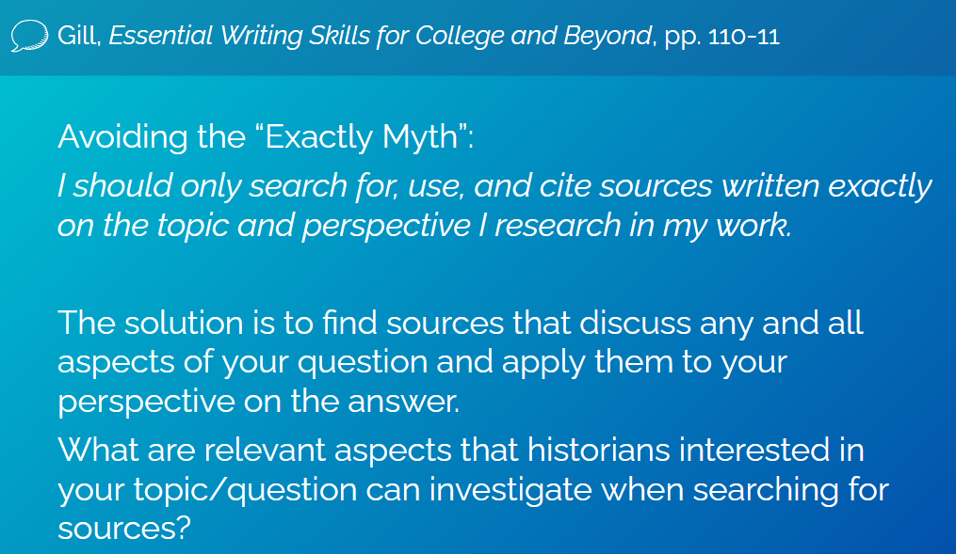

Refining Research Questions

The key to research is a good question that addresses a problem calling for analysis. Without posing a question, nothing you are doing can be called research.
A good question is what you need to move beyond merely gathering facts and information, reorganizing it (synthesis), and reporting on what you read.
With a question in the mix, the facts and information turn into the raw material needed to answer the question. The result is analysis that turns facts and information into evidence that can then be used to reach an answer.
Badke, Research Strategies, p. 49

Use what you’ve learned from the sources you’ve considered so far to identify/restate the “problem,” a controversy, puzzle, issue, in your topic area that you’re investigating. Your research question puts this “problem” at the center of your investigation.
Your essay interprets the evidence (sources) you selected, making connections among the information in those sources to build a compelling answer to the question. (You can think of that answer as a “solution” to the “problem,” or an educated guess.)

Formulate a single, clear question that states the goal of your quest.
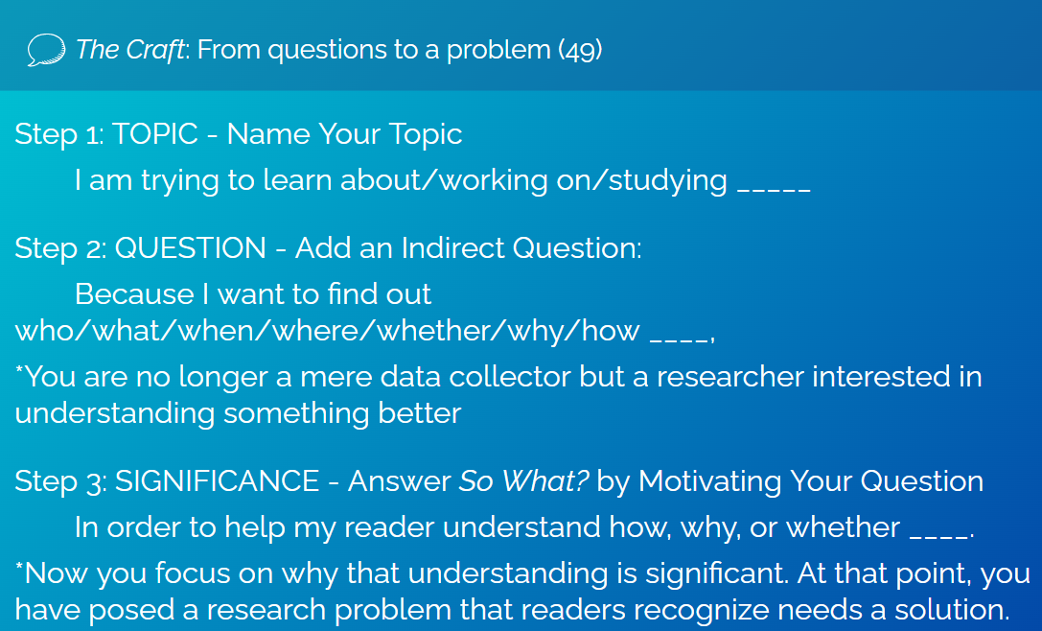
Step 1: Name Your Topic
I am trying to learn about/working on/studying _____
Fill in the blank with your topic, using a noun derived from verbs, e.g., conflict, description, contribution, development.
Step 2: Add an Indirect Question that indicates what you do not know or understand about your topic:
Because I want to find out who/what/when/where/whether/why/how ____.
When you add that because I want to find out how/why/whether clause, you state why you are pursuing your topic: to answer a question important to you.
Step 3: Answer So What? by Motivating Your Question
In order to help my reader understand how, why, or whether ____.
This question asks you to identify how the topic you’re interested in touches on issues important to the subject-area field. Answering this last question is your ticket into the conversation of the discipline’s/field’s community of researchers.
Consider: Change, Continuity, Causation, Consequence, Significance, Perspectives

